Linux Programming : Assignment-5
Name : Vigneshwaran P
Class:3C
USN : ENG24CY0069

- What is a bash shell script? Give one example.
Soln:
A bash shell script is a text file containing a series of commands that can be executed together.
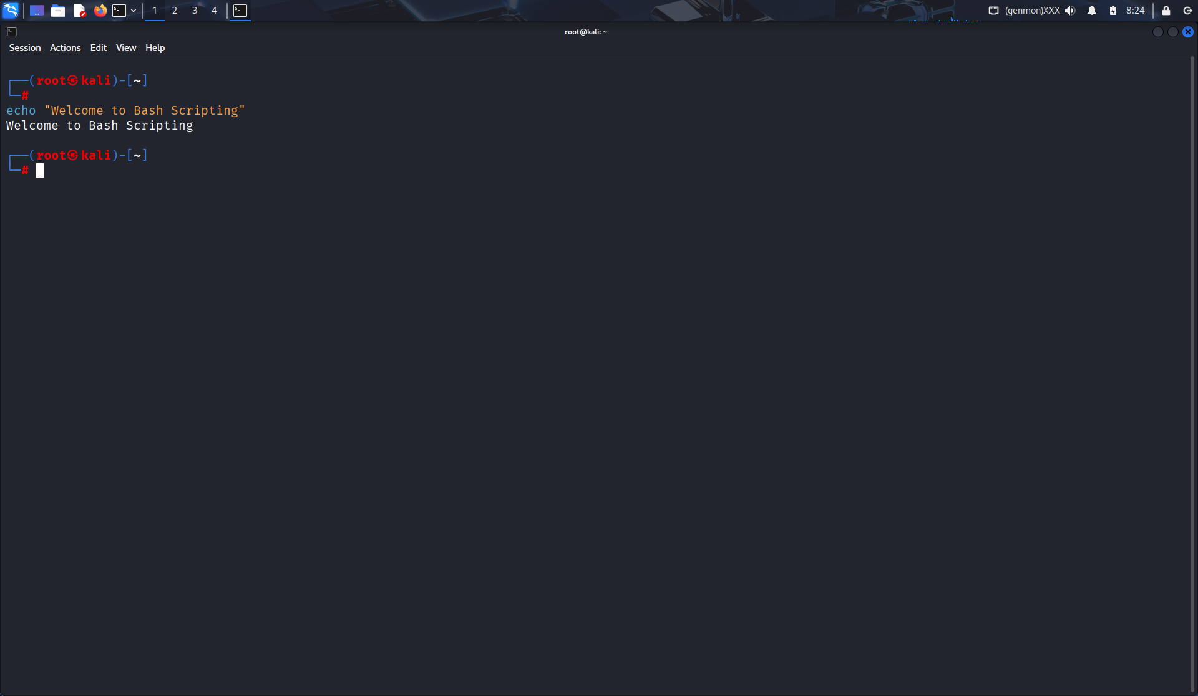

- Write a simple shell script to print “Hello World”.
Soln:
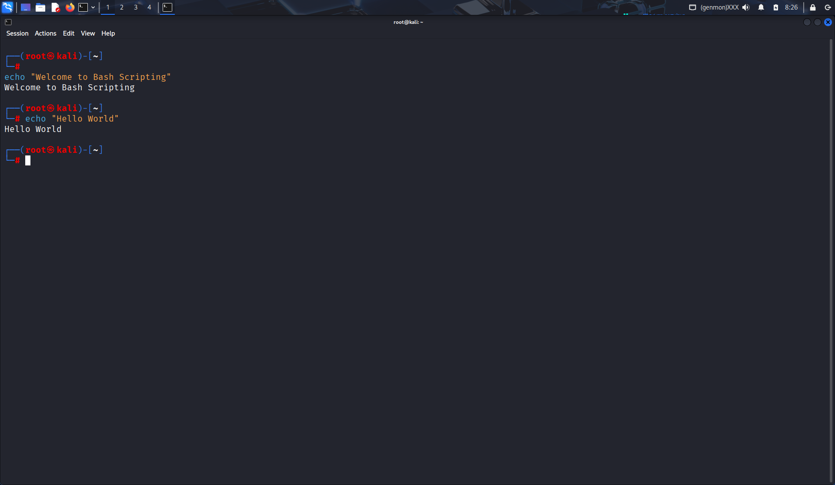

- What is the purpose of comments (#) in a shell script?
Soln: Comments (#) are used to add explanations or notes in scripts. They are ignored by the shell.

- How do you declare variables (int, float, double, string, Boolean, and char in a shell script?
Soln:
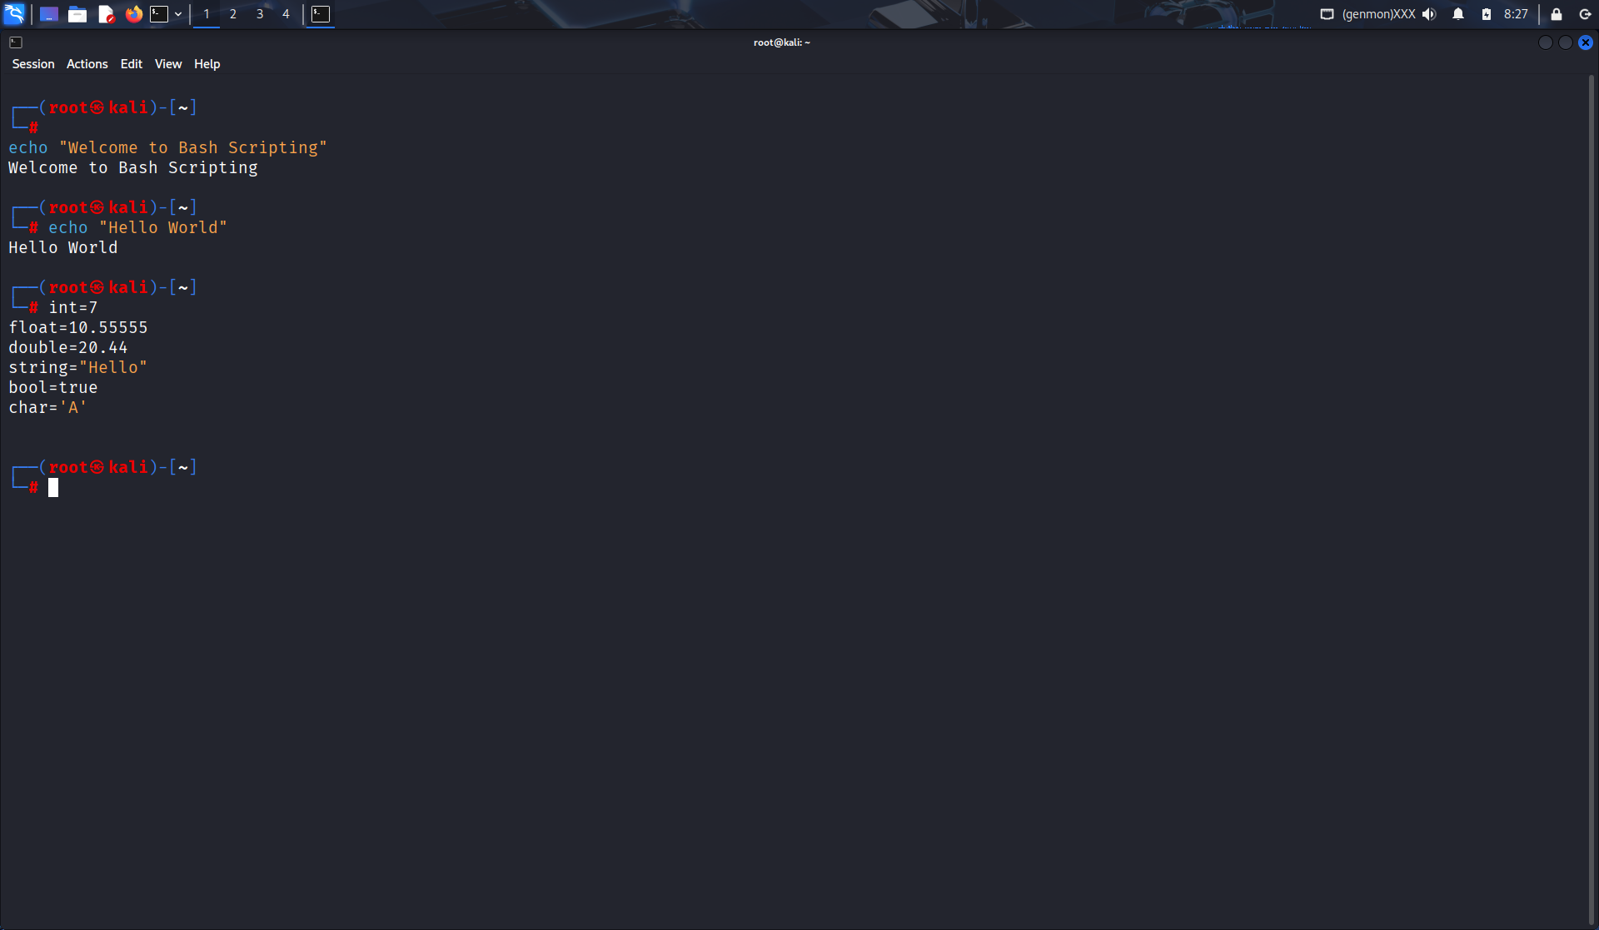

- Write a shell script to display the current date and time of the system.
Soln:
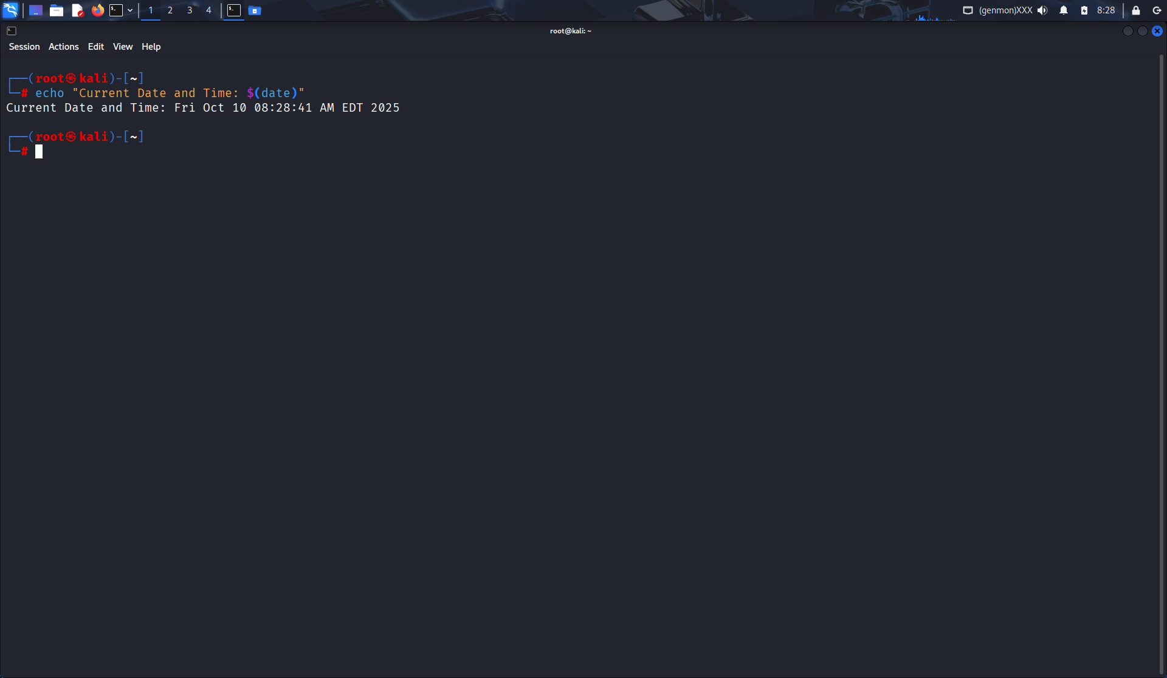

- Explain the difference between a constant and a variable in bash script.
Soln:
Variable: Value can change during execution.
Constant: Value remains fixed using readonly or declare -r.
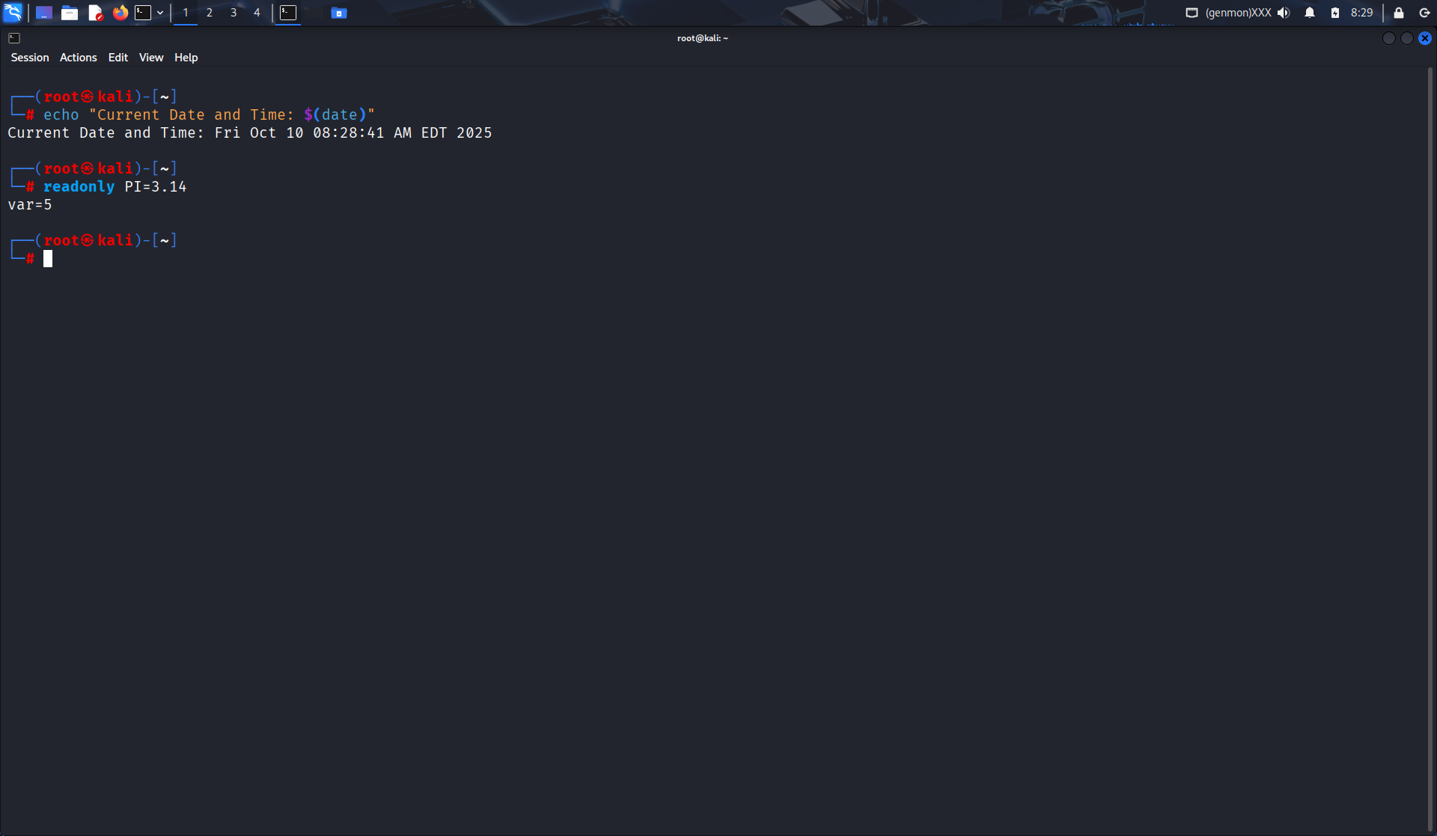

- Write a shell script to read two integer number from the user and compute the sum of both the number.
Soln:
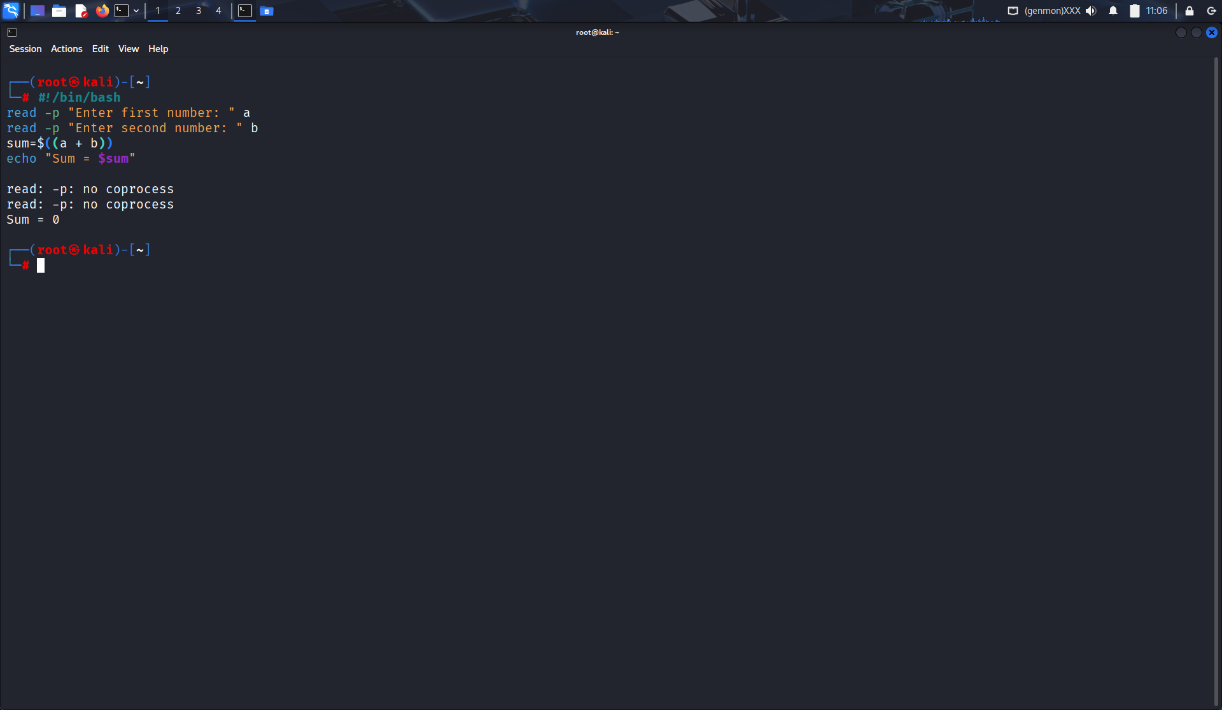
- What is the use of source command in shell scripting?
Soln:
source executes a script in the current shell, keeping environment variables.
Example:
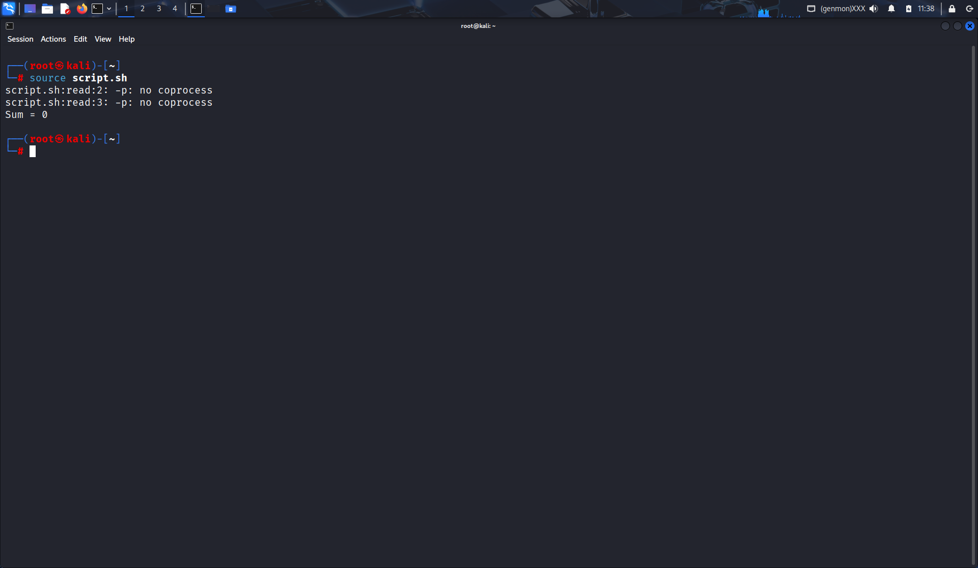

- How can you debug a shell script? Give two methods.
Soln:
Debug methods:
- Use bash -x script.sh
- Add set -x and set +x in script.

- Write a bash script to create and delete a file.
Soln:
